On behalf of the Billy McNeill Commemoration Charity,
we invite you to:
the Billy McNeill Annual Charity Dinner
‘In Honour of Cesar’
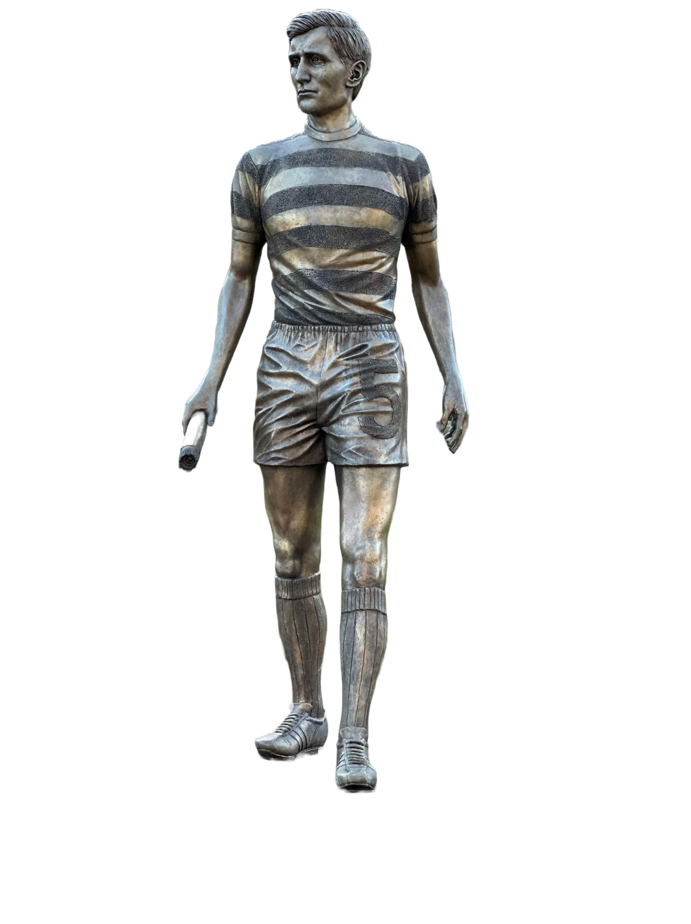
Kerrydale Suite at Celtic Park, Saturday 22nd March 2025, 7pm until late.

Compère Bernard Ponsonby
Entertainment David McKendrick & Pat Rolink (comedian)
Keynote Speaker Jim Black
Q and A “Celtic Memories” with Jackie McNamara
Guests Lisbon Lions, Celtic FC, McNeill family, Ex players, Showbiz personalities, Corporate guests Supporters clubs, The Celtic family

The Billy McNeill Commemoration Charity, supporting sporting excellence for youth, always will be remembered - Billy McNeill, Captain, Manager, Legend.

Tables seating ten are £700, or individual tickets are £70, which includes drinks on arrival, 3 course meal, a couple of bottles of wine on the table and a programme. There will be free buses to and from the event from Bellshill. (Kerrydale dress code: Smart, no jeans or trainers). Please let us know when booking, if you require the transport.
Contact: Eddie Lynas 07749826357 or BillyMcNeillCC@outlook.com

